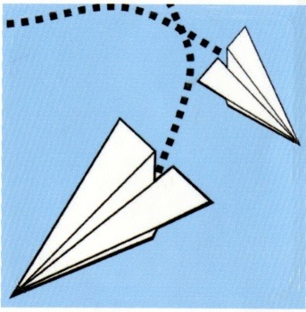
Third Annual Granville County Paper Chase
November 2015

We would like to welcome you to our third annual Granville County Paper Chase event. This fundraiser is to raise donations for Granville County United Way. This is a grown-up scavenger hunt, which is named after the book The Paper Chase by John J. Osborn. The goal is to become the first place winner of the Paper Chase. There will be a coveted prize to the first team who accomplishes this task. To accomplish this you must, as a team, go to several different sites around Granville County and collect clues on your scavenger hunt. Each clue will bring your team closer to the knowledge of the final gathering place location. Each team will go out and collect clues, which may or may not involve puzzle or riddle solving, completing challenges both mental and physical, or a dictionary. Each clue will take your team to the next clue site, and the next and the next until the final clue brings all the teams to the final gathering location in hopes of being the first team to finish.
Our third annual Granville County Paper Chase will be held on Saturday, November 7th from 9:15 am to 12 noon. The event will begin at JF Webb High School in Oxford. All team members will meet on the football field in the grassy area. This is where your adventure begins!
The team captain may choose any person to be on their team. Each team must have at least 6 team members and a maximum of 10. Each team must create an original team name. Each team member must pay an entrance fee of $30.00 and sign a participation waiver form. You are welcome as a team to seek sponsorships. Each team member is responsible for turning their paperwork and entrance fee into their team leader. Each team leader is responsible for turning their completed team packet of paperwork into Dinah Carter, United Way committee member, by October 15th at the Granville County Schools Central Office. The team captain will need to attend one informative meeting regarding the logistics of Paper Chase. The date will be determined after we have all the team packets on October 15th. The committee members for the Paper Chase this year are Brenda Dickerson-Daniel (919 691-0100), Samantha Chappell (919 699-8396), Jackie Baird (919 603-4522), Dinah Carter (919 691-7404) and Candi Perkins (252 438-2760). We will be glad to answer any questions you may have about the Paper Chase.

The rules of the Paper Chase are pretty simple and are listed below:
- Every Team must start at the same location and receive their scatter (first) clue.
- Directions for the Paper Chase will be read to all teams promptly at 9:30 am.
- All teams are given the exact same clues.
- All teams must complete all clues and follow the last clue to the final gathering place. A reception will be held there for all participants.
- You must complete the Paper Chase within a two hour time limit.
- No one else can join your team after the start of the Paper Chase.
- If one of your team mates must leave, the rest of the team will have to fend for themselves to finish the Paper Chase.
- All team members must travel together in one vehicle.
- Every member on the team must be on their honor to complete each riddle or puzzle, challenges and clues at each clue site. No short cuts!
- All team members must be together at each site and when they arrive at the final gathering place.
- Top prize will be given to the first team to complete the Paper Chase. Prizes will also be given at the gathering place for the most original team name, most spirited team and to the team that comes in last.
- No Paper Chase committee members may be on a team.
- Team members must 18 years old or older.
We are so glad that you are part of the Third Annual Granville County Paper Chase for United Way. Be sure to dress comfortable, you never know what you will be asked to do. Be creative! Teams may dress alike or wear costumes. Remember, there is a “Most Spirited Team” award. We want you to have fun while we all help a wonderful charity in our community. Thanks in advance for your support.

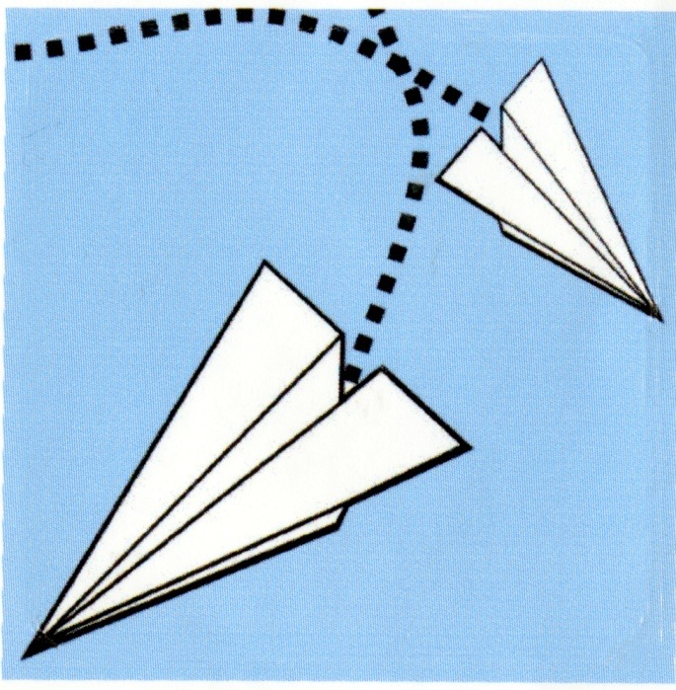

Third Annual Granville County Paper Chase Entrance form
Saturday, November 7th, 2015
Begin at JF Webb High School Football Field
9:15 a.m.-12:00 p.m. with reception following
Name of Team Member _________________________________________
Name of Team _______________________________________________
Team Member Telephone/Cell Number _____________________________
Paid Entrance Fee ______________________________________________

